Group Project 3 - Davis Update Package Notes
ApplyTrack - Singleton + Factory Pattern Refactoring and Deployment Testing
Prepared by: Davis Lukwago | Date: May 07, 2026

1. Purpose of This Update
This is my Davis' assigned Group Project 3 contribution and provides testing proof for the updated ApplyTrack package. The updated package focuses on Singleton and Factory pattern refactoring, confirming the project runs on Apache Tomcat v9.0, and verifying the database workflow through MySQL Workbench.

2. Work Completed by Davis
- Reviewed and tested the project locally using Eclipse and Apache Tomcat v9.0.
- Fixed the local database connection by updating the MySQL password in DatabaseUtil.java.
- Confirmed registration/login and dashboard loading after database connection was corrected.
- Tested adding, editing, and deleting job applications through the web application.
- Verified database persistence in MySQL Workbench after add, update, and delete actions.
- Confirmed ServiceFactory.java supports the Singleton + Factory approach by centralizing service object creation.
- Collected screenshots that can be used in the final report and video planning.

3. Testing Checklist
Test Area | Result | Evidence
Tomcat v9.0 deployment | Passed | Server startup screenshot in Eclipse console.
MySQL connection | Passed | App started working after matching MySQL password in DatabaseUtil.java.
User dashboard load | Passed | Dashboard displayed logged-in user and application counters.
Create application | Passed | Application added successfully and visible on dashboard.
Database insert | Passed | New application row visible in MySQL Workbench.
Update application | Passed | Status changed from Applied to Interviewing.
Delete application | Passed | Application removed from dashboard and database returned to original rows.
Singleton/Factory refactoring evidence | Passed | ServiceFactory.java screenshot shows singleton holder and factory creation method.

4. Design Pattern / Refactoring Notes for Report
The updated service layer uses ServiceFactory.java to centralize service object creation. This supports a Singleton-style approach because a single factory instance is exposed through getInstance(), while service access is routed through factory methods such as getAuthService(), getDashboardService(), and createService(ServiceType type).
This improves maintainability because servlets do not need to manually create service objects in multiple places. Instead, object creation is controlled in one location, making the code cleaner and easier to update. This directly supports the Group Project 3 rubric areas for code refinement, design patterns, code quality, and documentation.

5. Screenshots and Evidence
The screenshots below show the project running successfully, database verification, and the Singleton/Factory refactoring evidence.

Dashboard after creating a new application
The application was successfully added. Dashboard counts updated to show one total and one applied application.
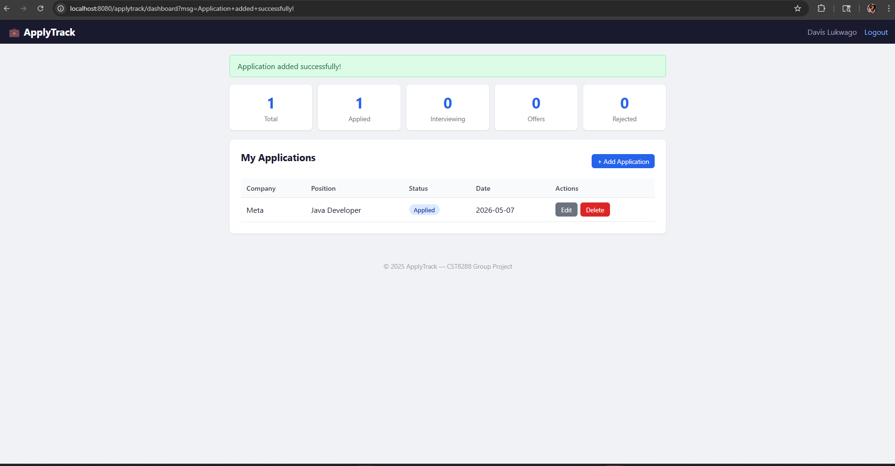
Figure 1: Dashboard after creating a new application

Edit application page loaded successfully
The Edit Application page opens with the existing application values populated for update.
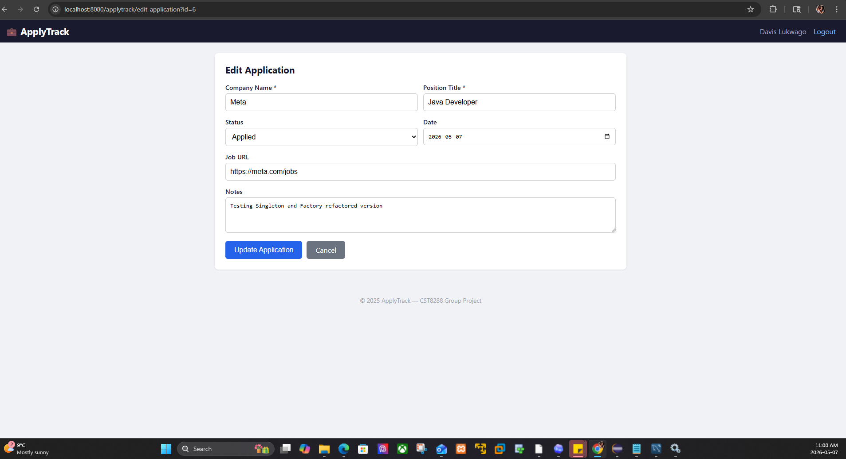
Figure 2: Edit application page loaded successfully

MySQL Workbench showing inserted application row
The applications table shows the newly inserted Meta / Java Developer record, confirming database persistence.
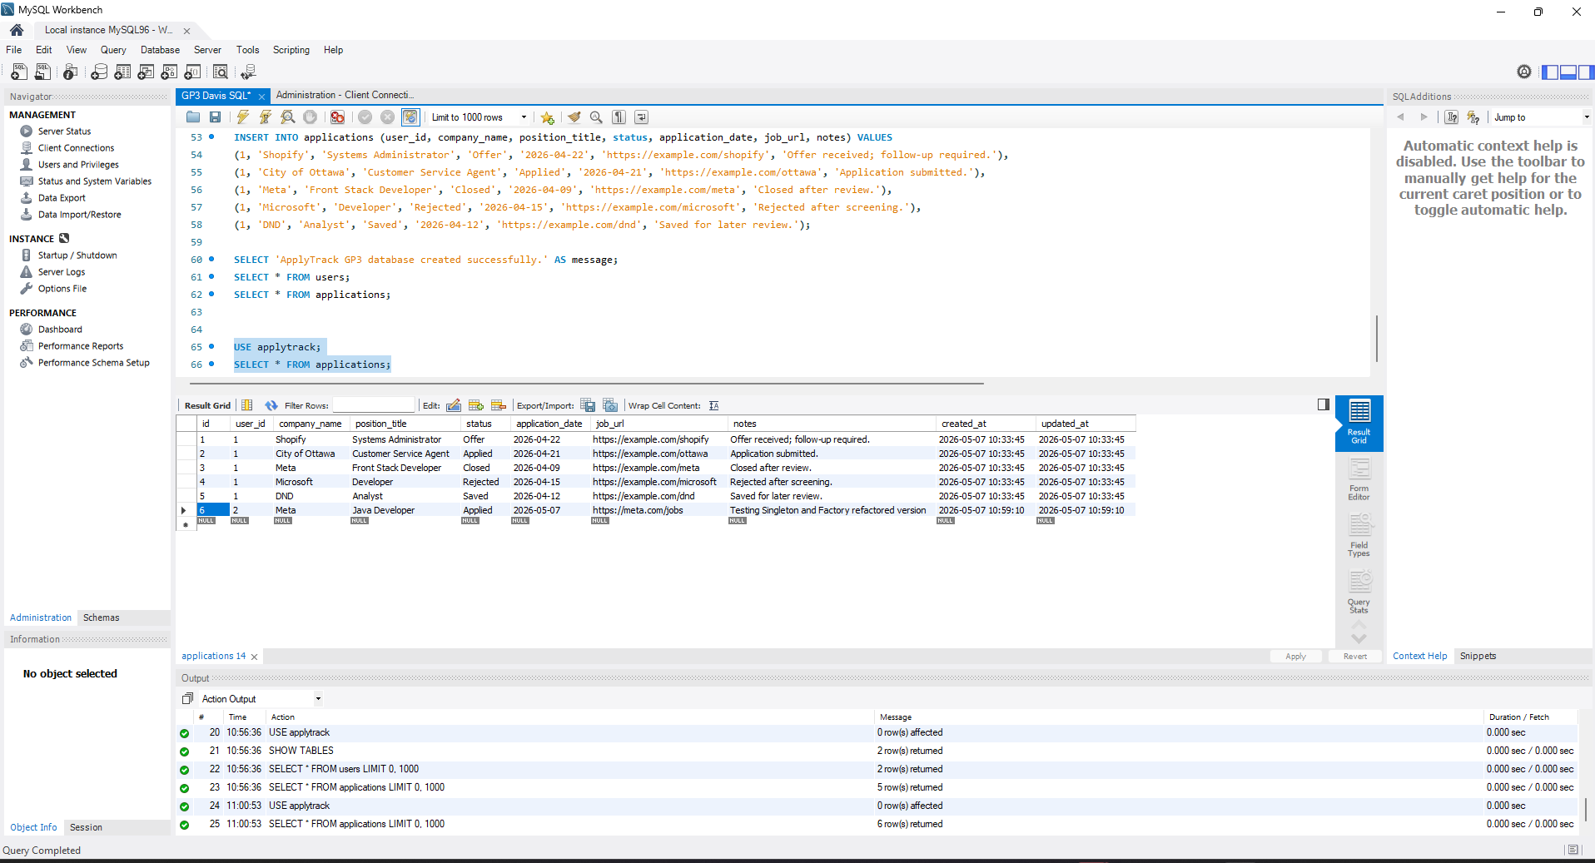
Figure 3: MySQL Workbench showing inserted application row

Dashboard after updating application
The application was updated successfully and the status changed to Interviewing.
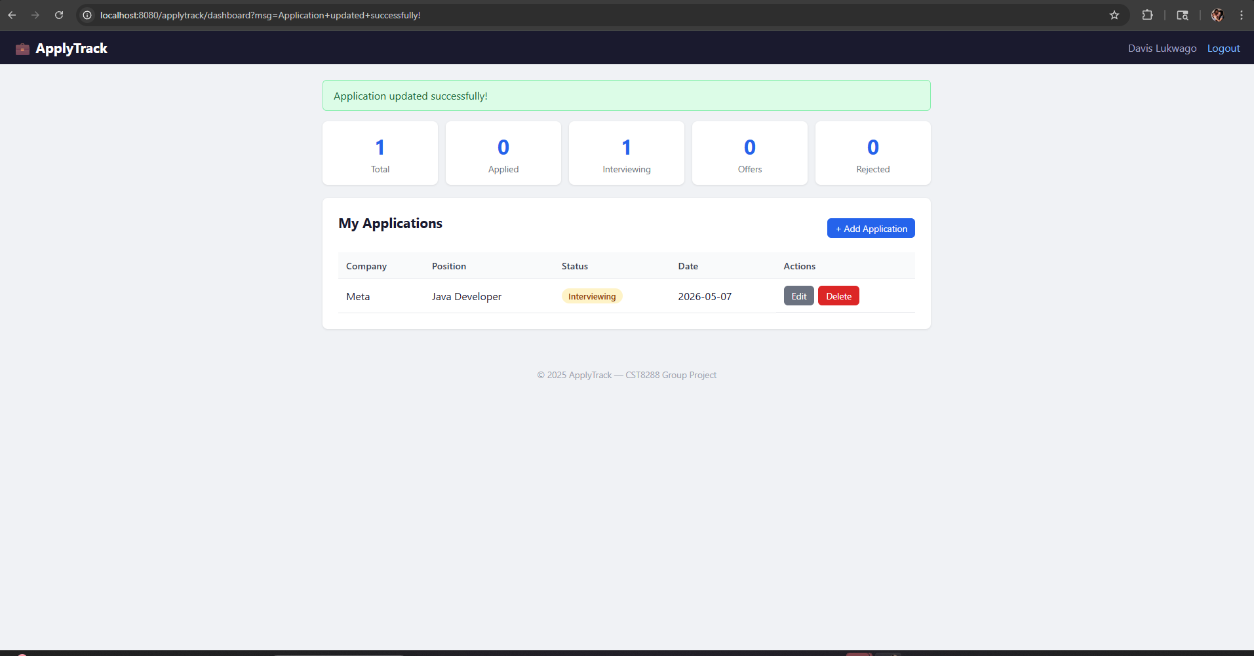
Figure 4: Dashboard after updating application

Edit form after modifying status and notes
The form displays updated values, confirming edit flow and data binding.
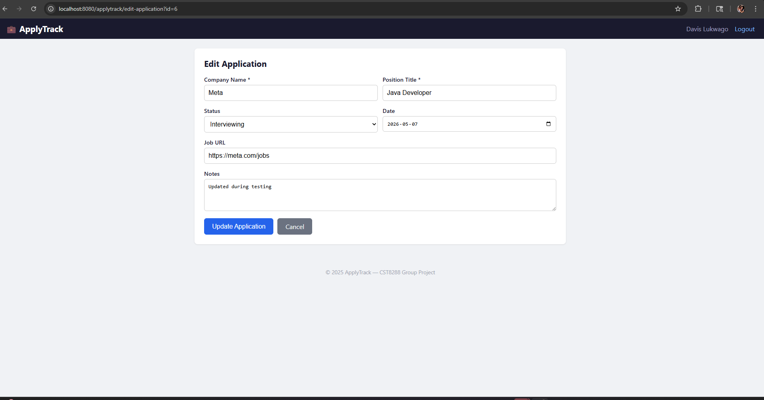
Figure 5: Edit form after modifying status and notes

Delete confirmation prompt
A browser confirmation prompt appears before deleting an application.
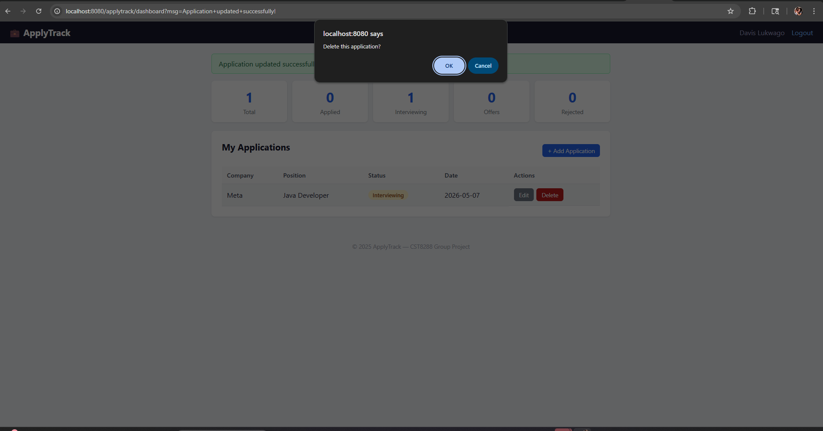
Figure 6: Delete confirmation prompt

Dashboard after deleting application
The application was deleted and the dashboard counts returned to zero.
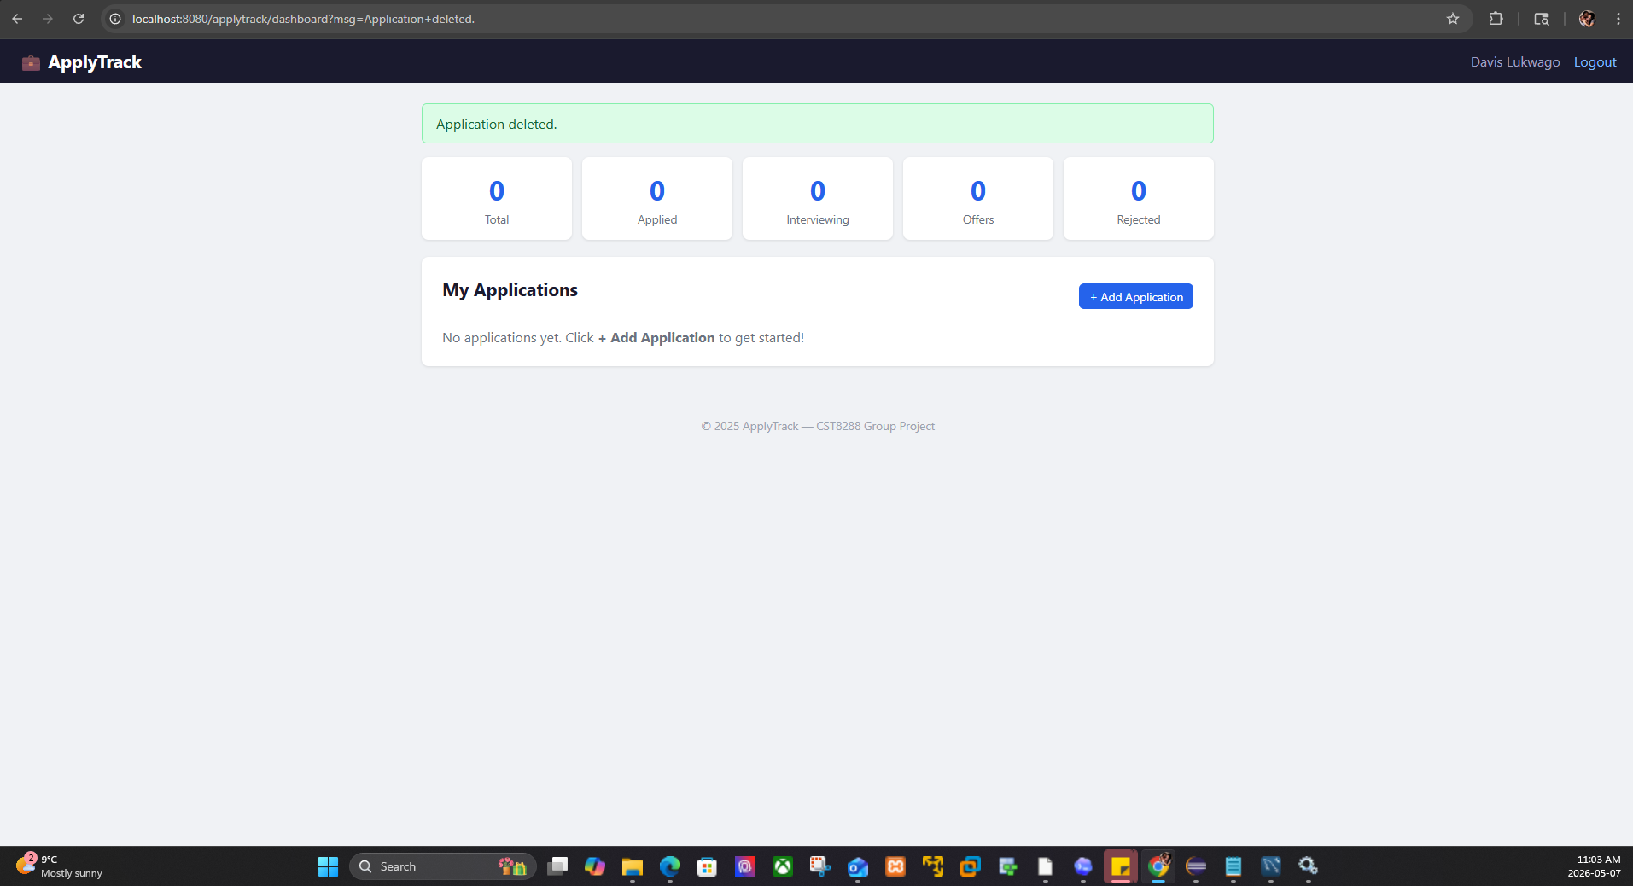
Figure 7: Dashboard after deleting application

MySQL Workbench after delete test
The applications table returned to the original sample rows after the test application was deleted.
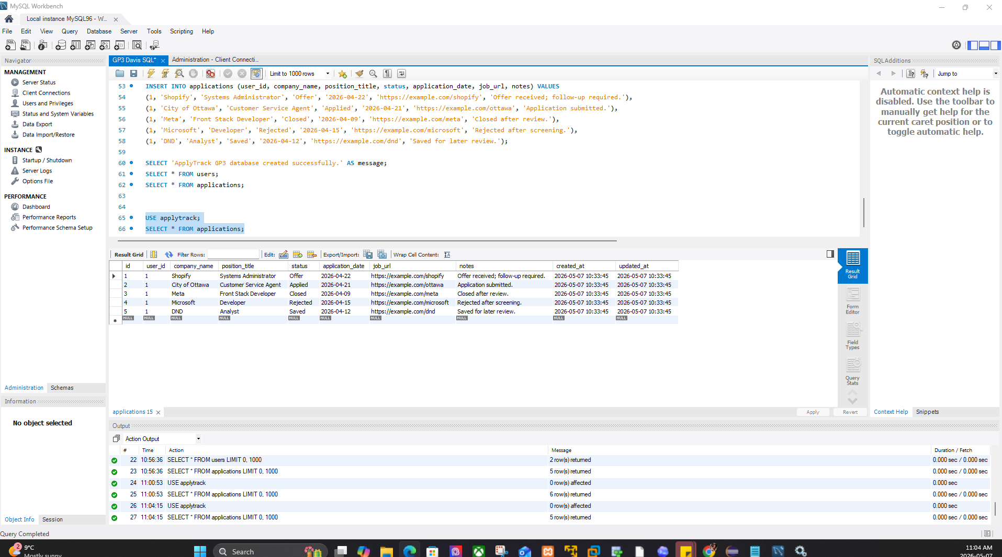
Figure 8: MySQL Workbench after delete test

DatabaseUtil.java connection configuration
DatabaseUtil centralizes database connection settings for MySQL deployment.
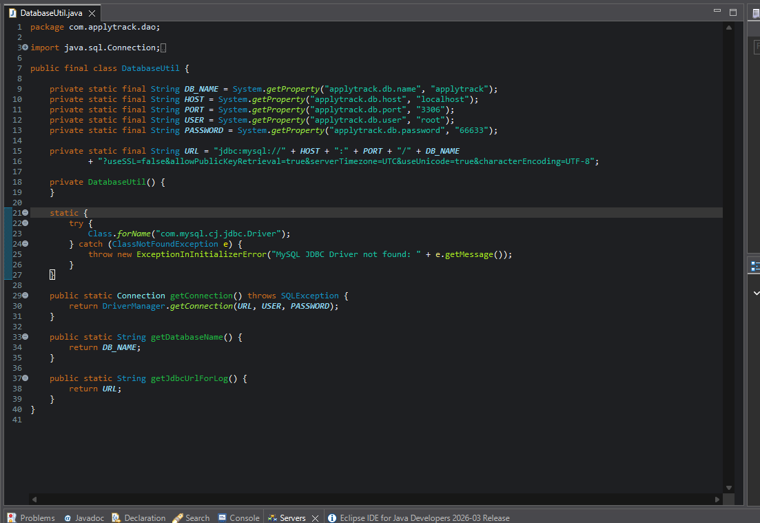
Figure 9: DatabaseUtil.java connection configuration

ServiceFactory.java Singleton and Factory implementation
ServiceFactory uses a singleton holder and provides factory methods for service objects.
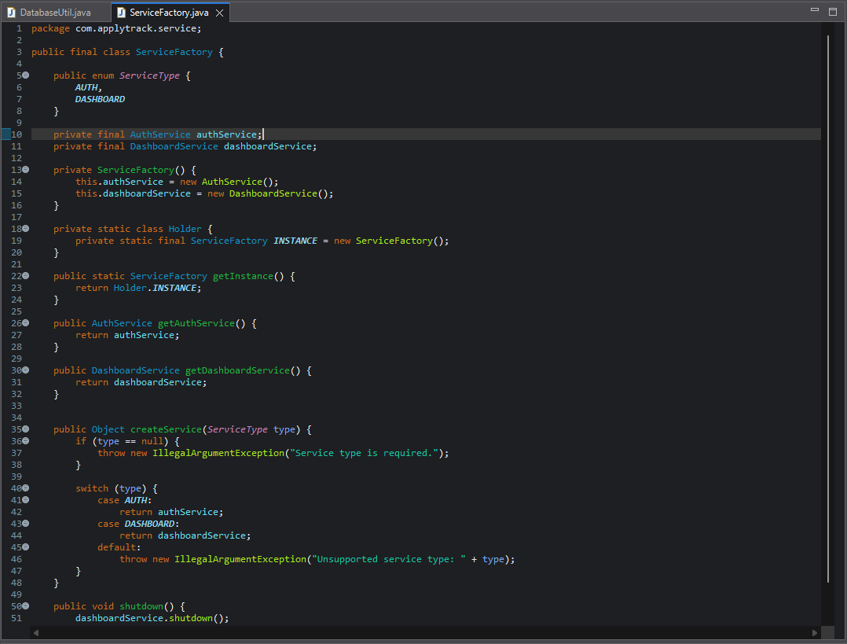
Figure 10: ServiceFactory.java Singleton and Factory implementation

Tomcat v9.0 server startup in Eclipse
Tomcat v9.0 starts successfully, confirming local deployment on Apache Tomcat 9.
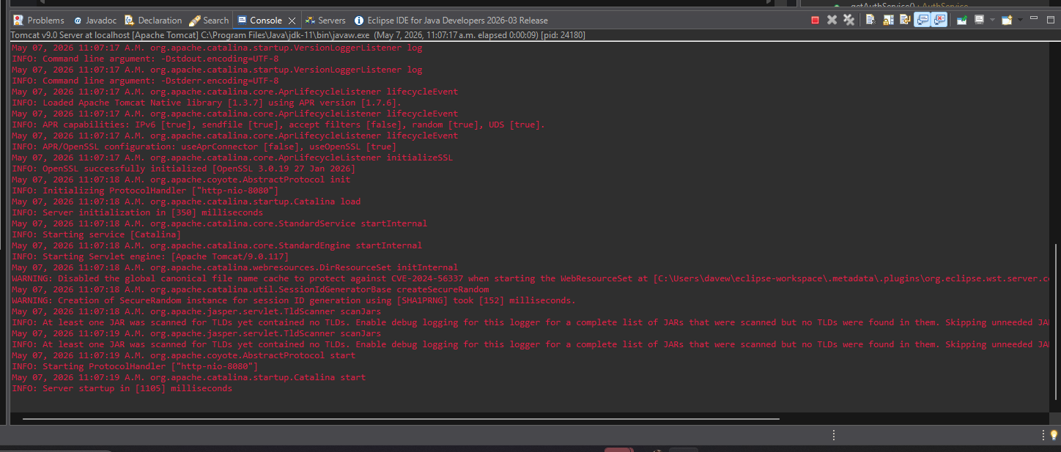
Figure 11: Tomcat v9.0 server startup in Eclipse

7. Suggested Message to Send with Package
Hi Demet and Paul,
I have tested the updated Group Project 3 package locally. The application runs on Apache Tomcat v9.0, connects successfully to the applytrack MySQL database, and the main workflows are working: registration/login, dashboard loading, add application, edit application, delete application, and database verification in MySQL Workbench.
For my assigned part, I focused on the Singleton and Factory pattern refactoring plus deployment testing. I also captured screenshots showing the app workflow, MySQL table verification, DatabaseUtil.java, ServiceFactory.java, and Tomcat v9.0 startup. These should help with the final report and video evidence.
I will send the source code ZIP, WAR file, and SQL file separately, along with this testing/evidence document. Please review and let me know if anything else needs to be adjusted before the final report and video are completed.
Kind regards,
Davis

8. Notes for Final Report
- Mention that the app was tested on Apache Tomcat v9.0.
- Include the ServiceFactory.java snippet in the design pattern/refactoring section.
- Mention DatabaseUtil.java under database connectivity/deployment configuration.
- Use the add/edit/delete screenshots in the testing evidence section.
- Use MySQL Workbench screenshots to prove database persistence.

